**Rabea Ahmed**

**CSE 498R**

**Weekly Progress Report**

*Week 2:*

Time: 18th to 25th July

Task:

1. Suggest improvements on the codes for the frontend of the following websites.

* <https://shantaholdings.com/>
* <https://akidabuilders.com/>

**Progress:**

**Shanta Holdings ltd.**

1. Better font- font used is lighter and not bold. Kind of blends in.

WITNESS, AS WE TRANSFORM  
YOUR LAND TO A LANDMARK

* Here, font-weight- increase, for making it bold
* font-color- change to a darker colour, like black #000000

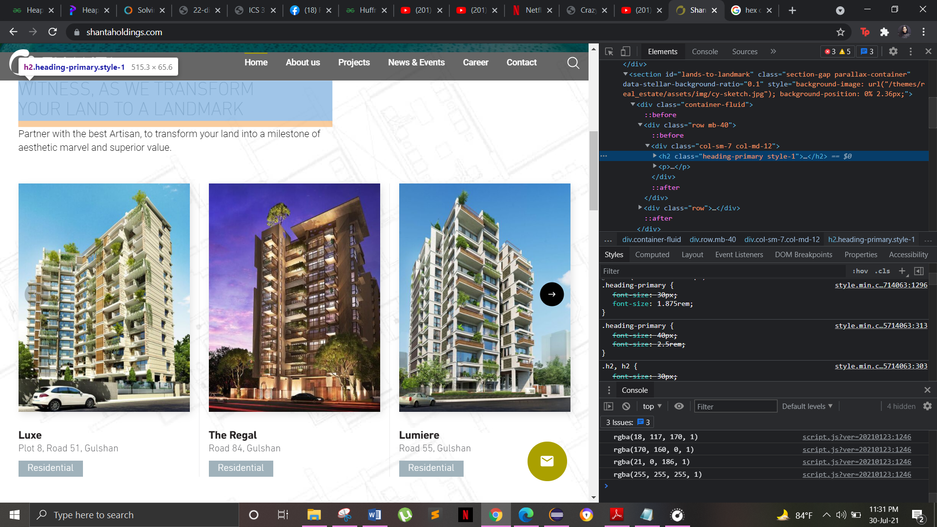

1. Homepage should have a short description about the company

Include a div right below the headlines and add a few lines about the company to give the visitors a brief idea about the company.

1. I don’t think the map on the home page was a wise decision

Slightly unnecessary for a homepage of a website to have a map. Remove the map from the main div (shown below).

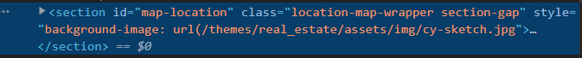

1. About us > our clients – these look like buttons but are not actual buttons. Gives a different color when hovered, so remove the hover option in the code.

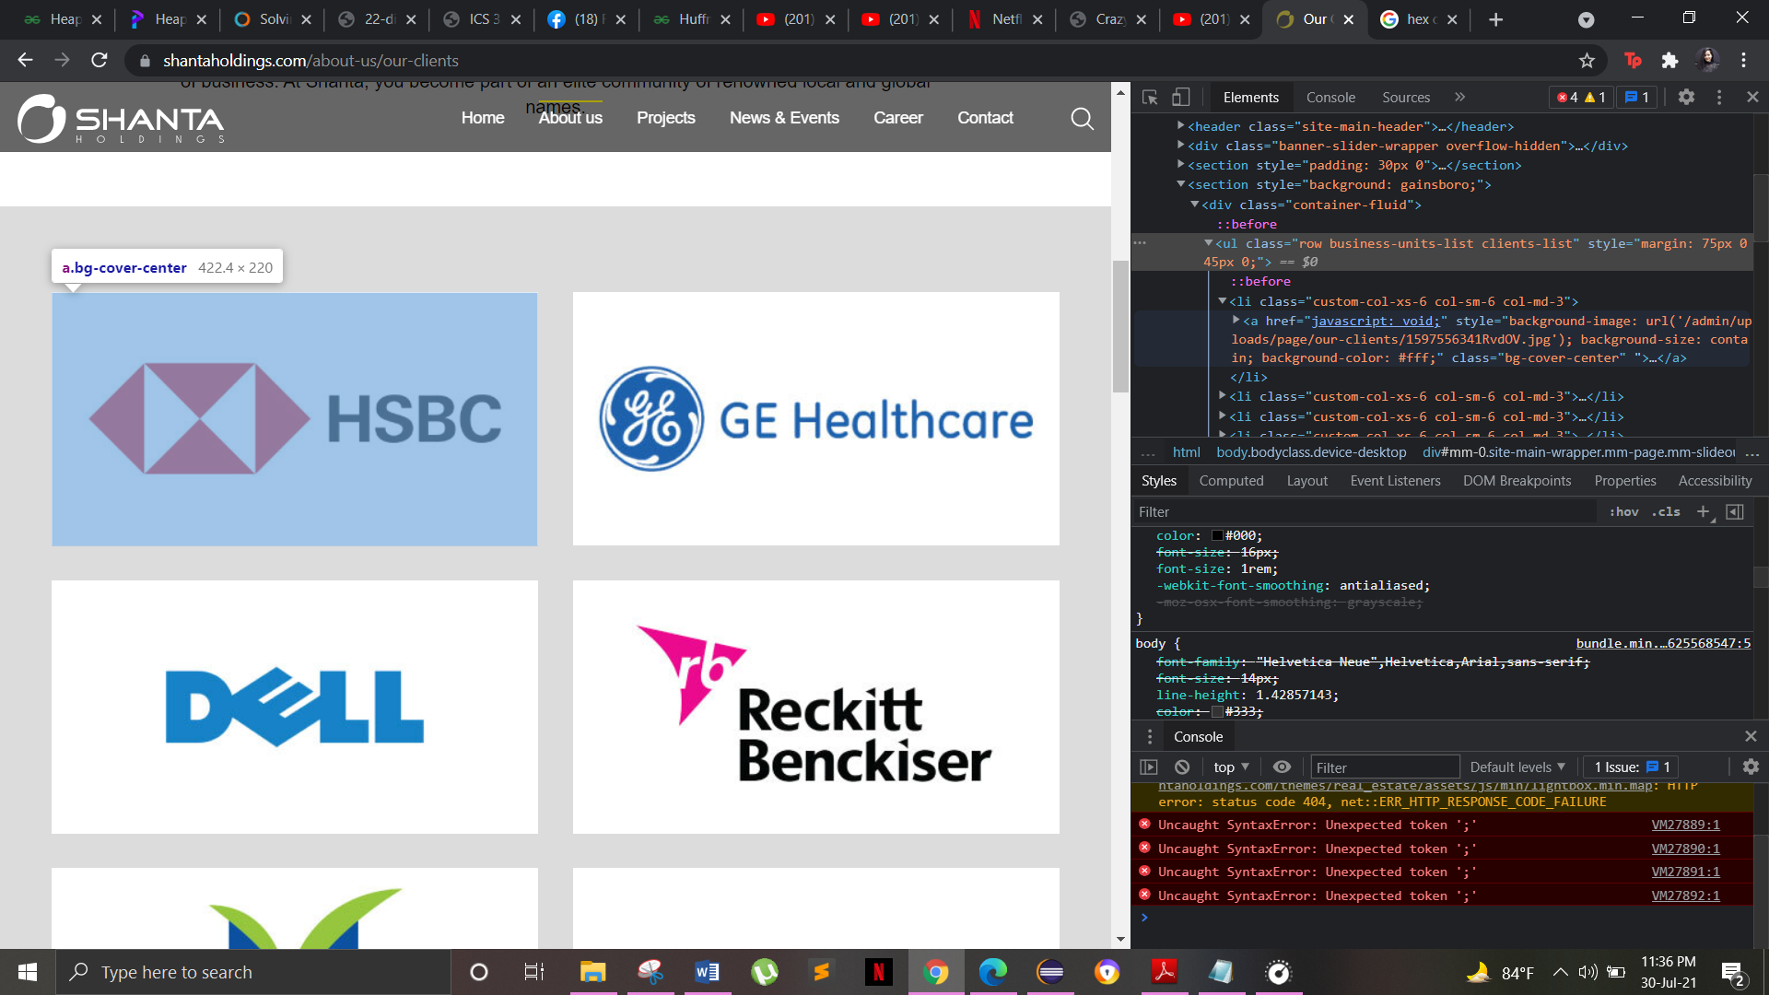

1. Project page – too much going on. Add some borders between the pictures maybe.

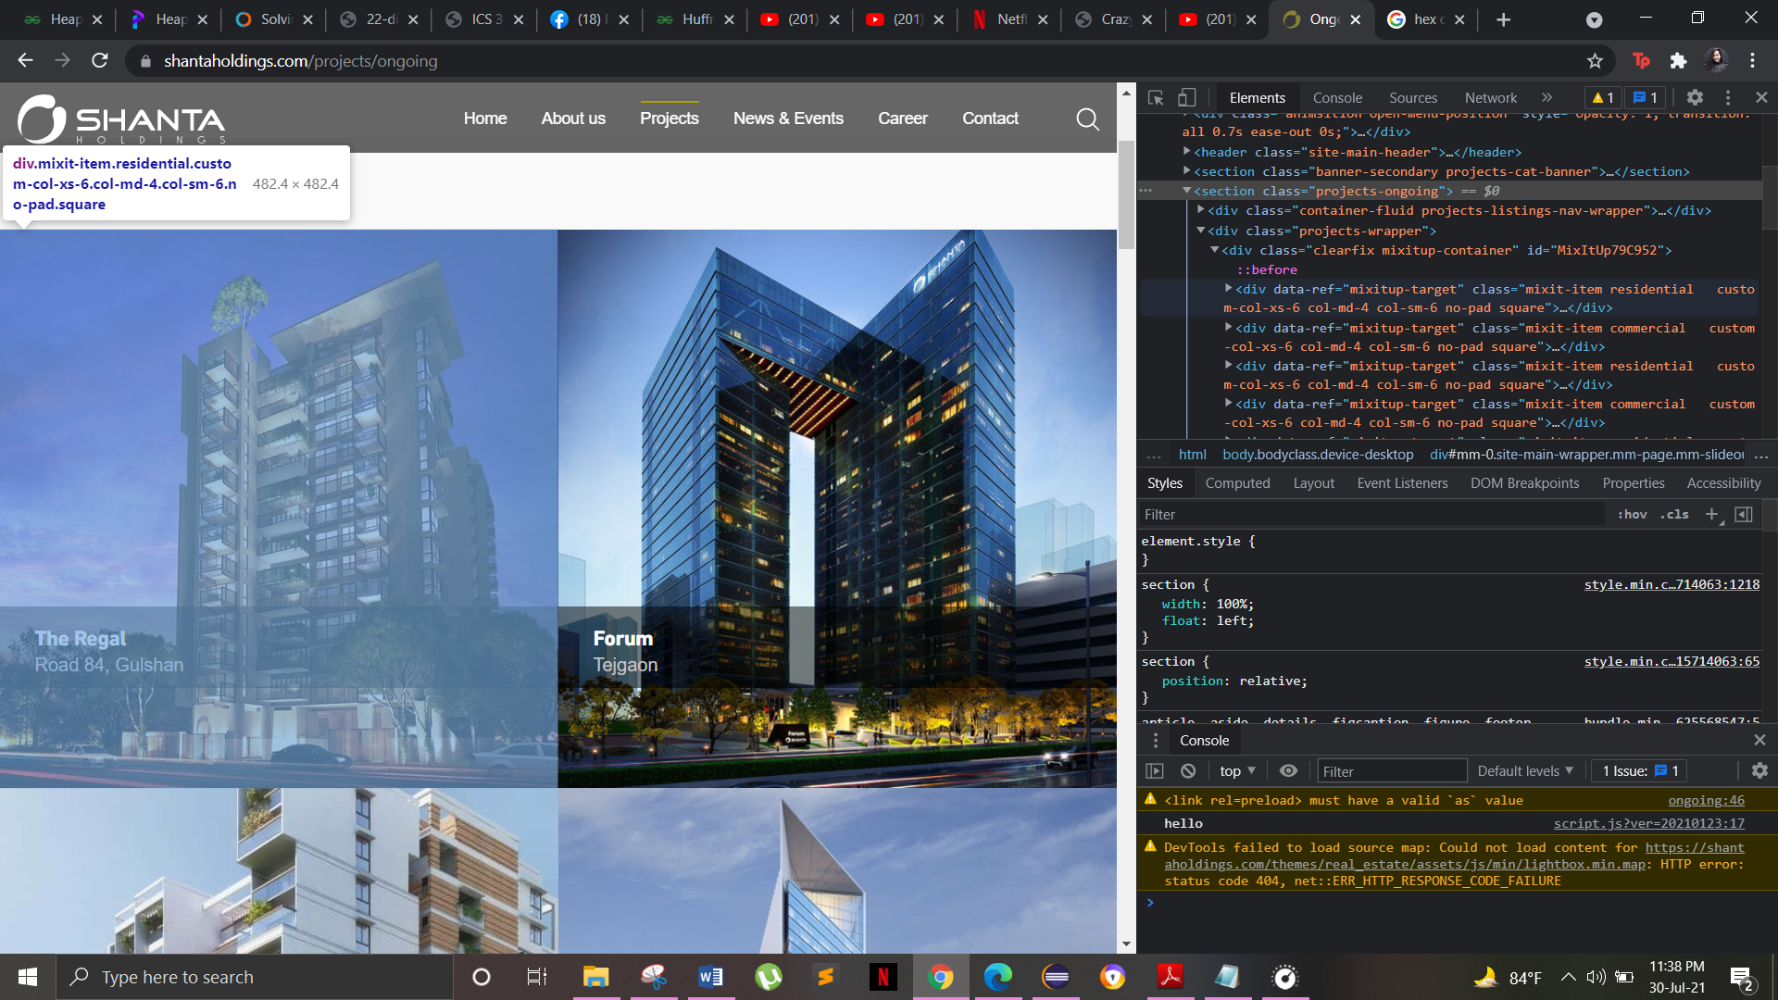

**Akida Paradise:**

Improvements:

1. The homepage image had some glitch.
2. The homepage could use better background images, it looks very simple now.

Some background colour in this div could make the front page a little more fancy.

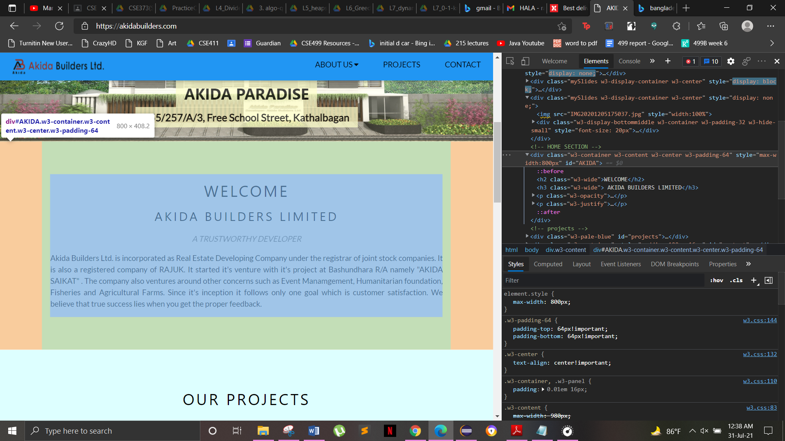

1. Home button is missing. Add a home button in this div.

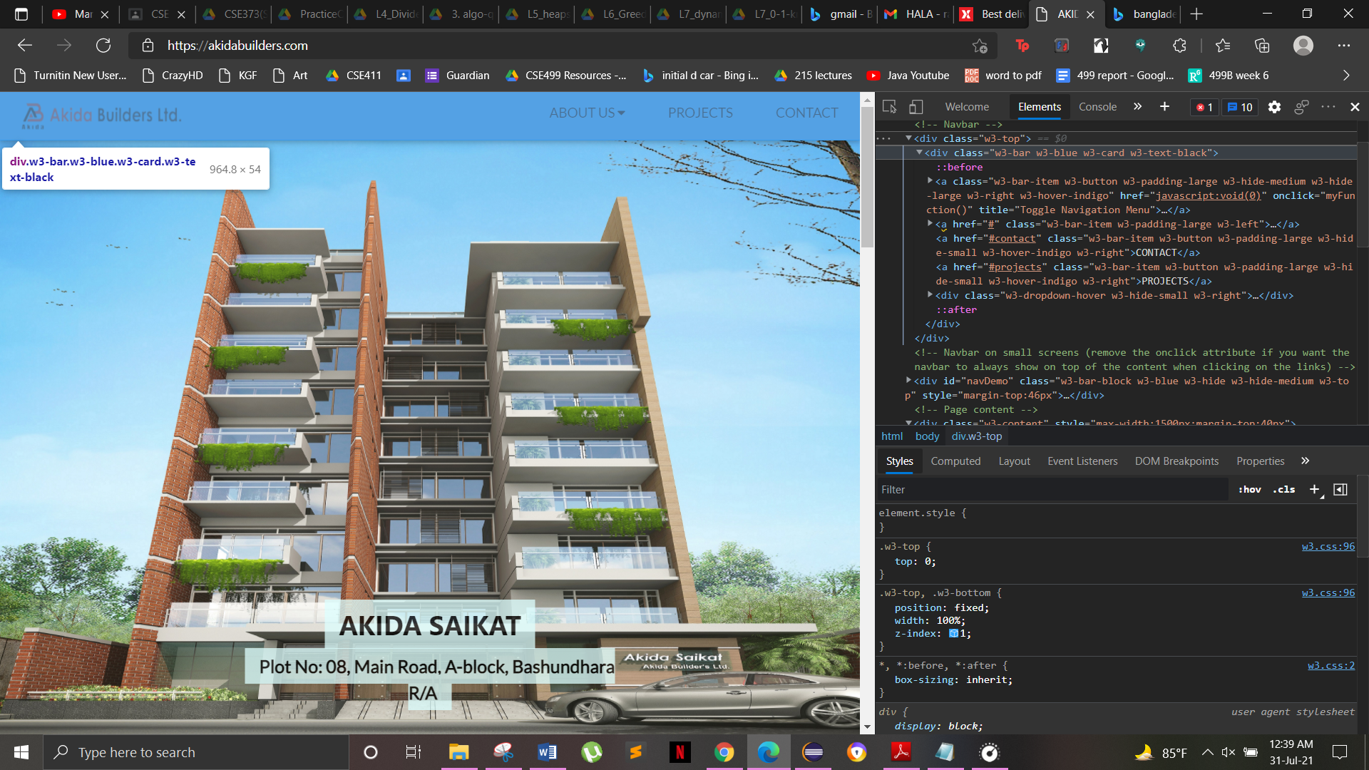

1. More functions can be added to enhance the usage of the website and give people more information.

For example

* More staff info
* A map showing where the company has built their projects so far
* Info on upcoming projects

1. Project page background and font could be better

Change background-color in css

